**Stock Valuation**

* Stockholders expect to be compensated for their investment in a firm’s shares through periodic **dividends** and **capital gains**.
* Investors purchase shares when they feel they are **undervalued** and sell them when they believe they are **overvalued**.

1. **Basic Common Stock Valuation Equation**

The value of a share of common stock is equal to the present value of all future cash flows (dividends) that it is expected to provide.

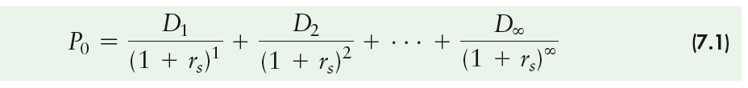

1. **Zero-Growth Model**

The **zero dividend growth** model assumes that the stock will pay the same dividend each year, year after year.

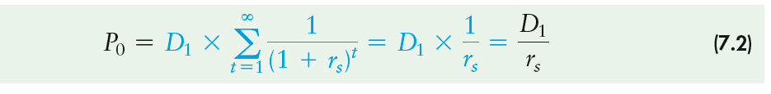

1. **Constant-Growth Mode**

The **constant-growth model** is a widely cited dividend valuation approach that assumes that dividends will grow at a constant rate, but a rate that is less than the required return.

The **Gordon model** is a common name for the constant-growth model that is widely cited in dividend valuation.

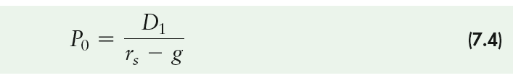

**Note**: The zero- and constant-growth common stock models do not allow for any shift in expected growth rates.

1. **Variable-Growth Model**

The zero- and constant-growth common stock models do not allow for any shift in expected growth rates.

The **variable-growth model** is a dividend valuation approach that allows for a change in the dividend growth rate.

**Step 1.** Find the value of the cash dividends at the end of each year, *Dt*, during the initial growth period, years 1 though *N*.

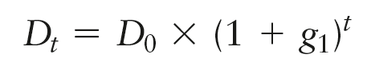

**Step 2.** Find the present value of the dividends expected during the initial growth period.

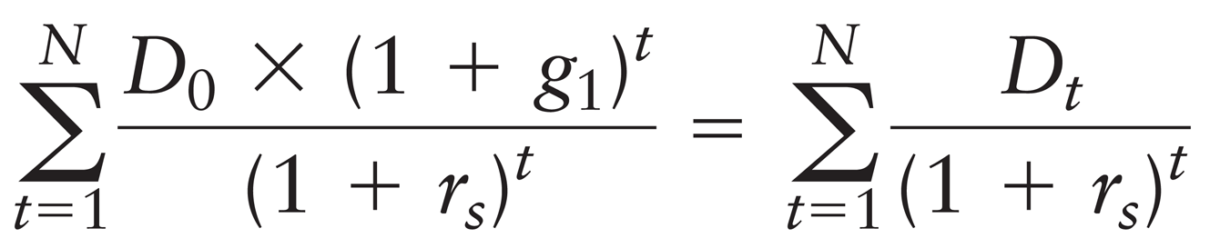

**Step 3.** Find the value of the stock at the end of the initial growth period, *PN* = (*DN*+1)/(*rs*– *g*2), which is the present value of all dividends expected from year *N* + 1 to infinity, assuming a constant dividend growth rate, *g*2.

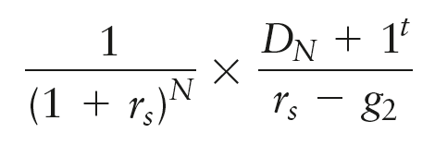

**Step 4.** Add the present value components found in Steps 2 and 3 to find the value of the stock, *P*0.

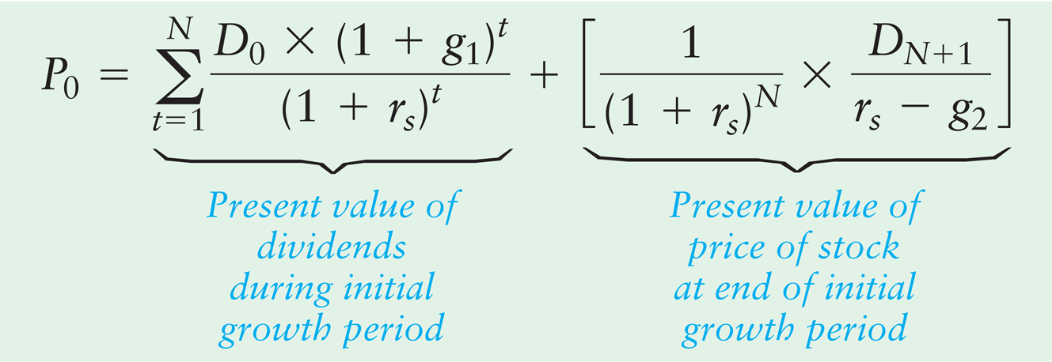

**Note:** If the company will pay fixed amount of dividends for a specific time as if the company decided to distribute 5 dollar dividends per share for every year in the next 7 years. We can calculate the intrinsic value through the following formula:



**Ex1.** Chuck Swimmer estimates that the dividend of Denham Company, an established textile producer, is expected to remain constant at $3 per share indefinitely. If his required return on its stock is 15%. Calculate the fair value of the stock.

**Answer**



**The stock’s value is 20 ($3 / 0.15) per share.**

**Ex2.** Chuck Swimmer estimates that the dividend of Denham Company, an established textile producer, is expected to grow constant at 7% per share indefinitely. If his required return on its stock is 15% and last dividends paid in $11. Calculate the fair value of the stock.

**Answer**



**D1 = D0 x (1+g) = 11 x (1+7%) = 11.77**

**P0 = 11.77 / 15% - 7% = 147.125**

**Ex3.** Chuck Swimmer estimates that the dividend of Denham Company, an established textile producer, is expected the following dividends 3, 4, 9, 11 for the next four years then the company won't pay anymore dividends. If his required return on its stock is 15% and last dividends paid in $11. Calculate the fair value of the stock. **Answer**



**P0 = 3 / (1+15%) 1 + 4 / (1+15%) 2 + 9 / (1+15%) 3 + 11 / (1+15%) 4 = 17.84**

**Ex4.** Chuck Swimmer estimates that the dividend of Denham Company, an established textile producer, is expected the following dividends 3, 4, 9, 11 for the next four years then the company will have a constant growth dividend of 8% indefinitely. If his required return on its stock is 15% and last dividends paid in $11. Calculate the fair value of the stock.

**Answer**

**P0 = 3 / (1+15%) 1 + 4 / (1+15%) 2 + 9 / (1+15%) 3 + 11 / (1+15%) 4 + p4 / (1+15%)4**

**P4 = D5 / r – g**

**D5 = D4 x (1+g) = 11 x (1+8%) = 11.88**

**P4 = 11.88 / 15% - 8% = 169.71**

**p4 / (1+15%) 4 = 169.71 / (1+15%) 4 = 97.03**

**P0 = 17.84 + 97.03 = 114.87**

**Ex5.** The most recent annual dividend payment of Red Sea Industries, a rapidly growing boat manufacturer was US$1.50 per share. The firm’s financial manager expects that these dividends will increase at a 10 percent annual rate, *g*1, over the next three years. At the end of three years, the firm’s mature product line is expected to result in a slowing of the dividend growth rate to 5 percent per year, *g*2, for the foreseeable future. The firm’s required return, *rs*, is 15 percent.

**Answer**

**D0 = $1.50 g1 = 10% g2 = 5% r = 15%**

**D1 = D0 x (1 + g1) 1 = 1.50 x (1+10%) 1 = 1.65**

**D2 = D0 x (1 + g1) 2 = 1.50 x (1+10%) 2 = 1.815**

**D3 = D0 x (1 + g1) 3 = 1.50 x (1+10%) 3 = 1.9965**

**P0 = 1.65 / (1+15%) 1 + 1.815 / (1+15%) 2 + 1.9965 / (1+15%) 3 + p3 / (1+15%) 3**

**P3 = D4 / r – g2**

**D4 = D3 x (1+g2) = 1.9965 x (1+5%) = 2.096**

**P3 = D4 / r – g2 = 2.096 / 15% - 5% = 20.96**

**P0 = 1.65 / (1+15%) 1 + 1.815 / (1+15%) 2 + 1.9965 / (1+15%) 3 + 20.96 / (1+15%) 3**

**= 17.893**